A000- Afr-Nigeria-Yoruba-Mask-Divination-mid 20th c

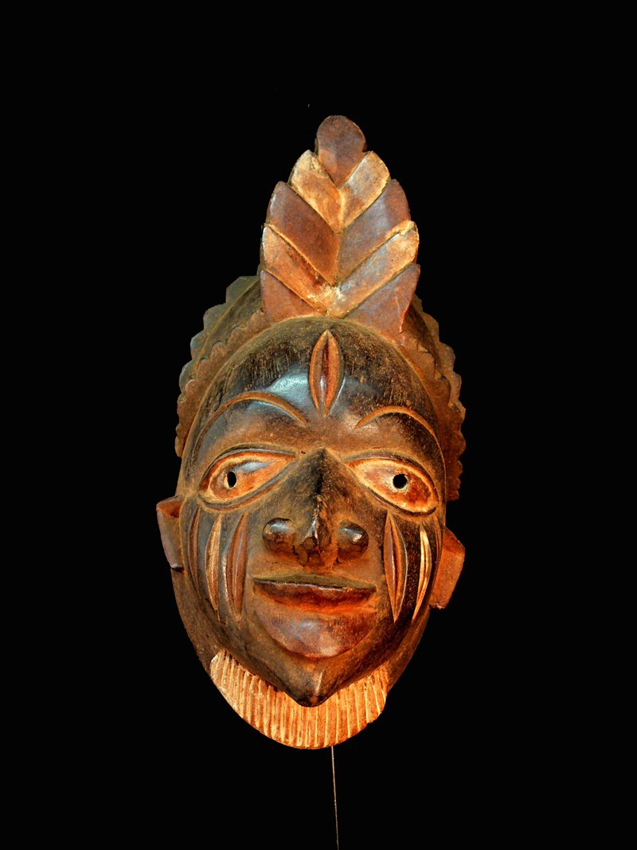 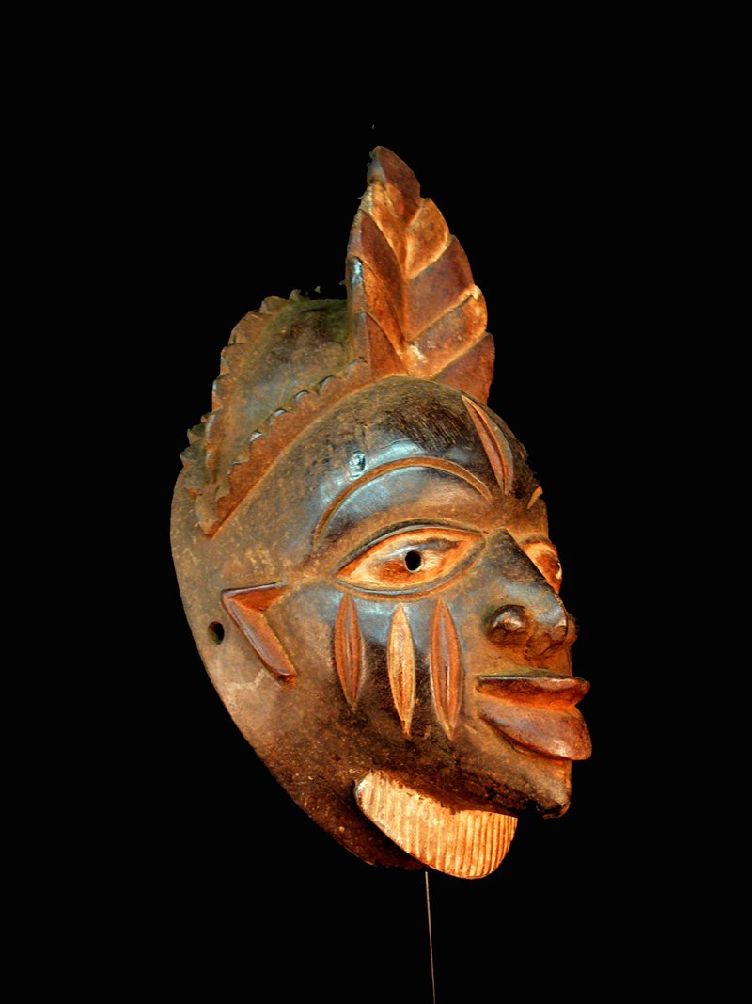 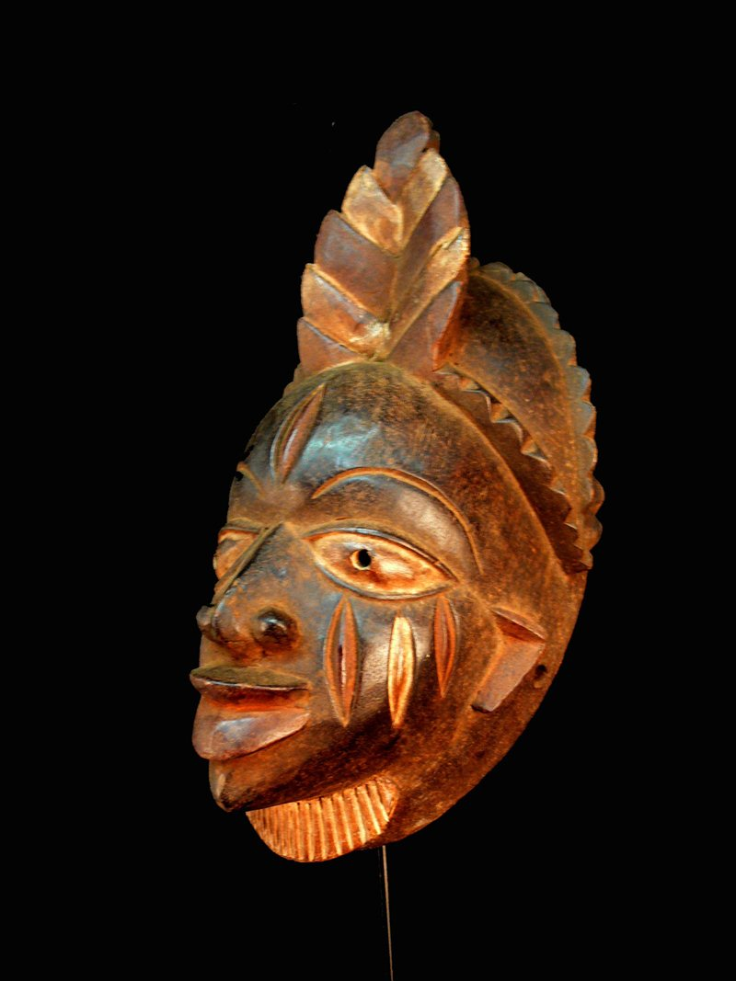 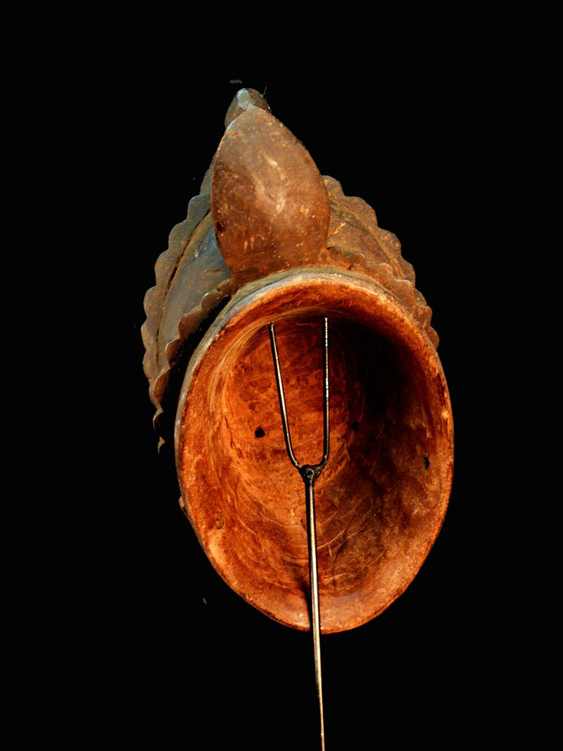

Figs. 1-4. Afr-Nigeria-Yoruba-Mask-Divination-mid 20th c

Case No.: 6

**Accession No.**

Case No.: 6

**Formal Label:** Afr-Nigeria-Yoruba-Mask-Divination-mid 20th c

**Display Description:**

Yoruba masks are worn by a traditional healer to drive evil spirits from the possessed person. The arts of the Yoruba are numerous in form. Beautifully carved art pieces are placed on shrines to honor the ancestors, which has resulted in varied masking traditions that has resulted in a great diversity of mask forms. In this example the keloids or scarifications are idiosyncratic, which suggests that this mask is of a deceased ancestor, whose feather headdress indicates that he has flown to the hereafter but is available in consultation much like an oracle when the mask is worn by a diviner who has been specially prepared. The mask acts as a connection between the spiritual universe and that of mortals through a series of complicatedquestions offered by the diviner, whose rôle is to function as an aid to preventing illness or forestalling bad luck.

**LC Classification:**

**Date or Time Horizon: mid 20th c**

**Geographical Area:**

**Map:**

**GPS coordinates:**

**Cultural Affiliation:**

**Media:**

**Dimensions:** 14.173 in

**Weight:** 2.125 pounds

**Condition:**

**Provenance:**

**Discussion:**

**References:**

Bascomb, William. [1969] 1991. *Ifa divination: communication between gods and men in west Africa* Bloomington and Indianapolis: Indiana University Press.

Thompson, R. F. [1971] 1976. *Black Gods and Kings: Yoruba Art at UCLA*. [Originally published as: Occasional Paper, No. II, Museum and Laboratories of Ethnic Arts and Technology, University of California, Los Angeles] (Bloomington, London: Indiana University Press, 1976)

Hans Witte, The Yoruba Artist, in Abiodun Rowland, John Pemberton, III, Henry J. Drewal, eds. 1994. *The Yoruba Artist: New Theoretical Perspectives on African Arts*. Washington, D.C.: Smithsonian Books.